FWC IITH INTERNSHIP
DIGITAL – DESIGN
ESP:
In digital design, ESP typically refers to Event-Stream Processing rather than the more commonly known term "Extra Sensory Perception." Event-Stream Processing is a paradigm used in the design and implementation of systems that deal with real-time event data. This approach is particularly valuable in applications where timely and efficient processing of events is crucial, such as in financial trading systems, telecommunications, IoT (Internet of Things) applications, and more.
Let's delve into the key aspects of Event-Stream Processing in the context of digital design:
1. **Definition:**
Event-Stream Processing involves the analysis and processing of a continuous flow of events or messages in real-time. Events are discrete occurrences or updates that happen in a system and are usually time-stamped. Examples include sensor readings, user interactions, system notifications, etc.
2. **Characteristics:**
- **Real-Time Processing:** ESP systems operate on live data as it arrives, providing insights and responses in near real-time.
- **Continuous Data Flow:** Instead of processing data in batches, ESP systems handle a continuous stream of events, allowing for quick response to changing conditions.
- **Temporal Logic:** Often, ESP systems consider the temporal aspect of events, understanding the order and timing of events to derive meaningful insights.
3. **Architecture:**
- **Event Sources:** These are the entities generating events, such as sensors, user interfaces, or external systems.
- **Event Processors:** The core components of ESP systems, these processors analyze and act upon incoming events. They can include filters, aggregators, pattern matchers, and more.
- **Event Sinks:** These are the endpoints where processed results or actions are directed. Examples include databases, dashboards, or other systems.
4. **Key Concepts:**
- **Event Patterns:** Descriptions of sequences or combinations of events that trigger specific actions or responses.
- **Windowing:** Techniques to group and analyze events within a specific time or count window.
- **State Management:** Handling and maintaining state information about ongoing processes, which is crucial for analyzing event streams over time.
5. **Use Cases:**
- **Financial Trading:** Detecting patterns or anomalies in stock market data.
- **Telecommunications:** Monitoring and managing network events for performance optimization.
- **IoT Applications:** Processing sensor data for smart homes, industrial automation, etc.
- **Fraud Detection:** Identifying suspicious patterns in transaction data.
6. **Challenges:**
- **Scalability:** Handling a large number of events per second.
- **Fault Tolerance:** Ensuring the system continues to operate in the presence of failures.
- **Complexity:** Designing and maintaining complex event processing logic.
7. **Tools and Technologies:**
- **Apache Flink, Apache Kafka, Apache Storm:** Open-source tools for stream processing.
- **AWS Kinesis, Azure Stream Analytics:** Cloud-based services for event-stream processing.
In summary, Event-Stream Processing in digital design provides a powerful way to analyze and respond to real-time events, making it essential for applications that demand rapid and dynamic data processing.

ESP-32:
The ESP32 is a highly versatile and widely used microcontroller developed by Espressif Systems. It's renowned for its low cost, low power consumption, and integration of Wi-Fi and Bluetooth capabilities, making it a popular choice for a wide range of embedded applications, including IoT devices, wearables, home automation systems, and more. Let's explore its key features, architecture, applications, and development environment in detail:
### Key Features:
1. **Dual-core Processor:** The ESP32 features two Tensilica LX6 microprocessor cores, which can be independently controlled. This dual-core architecture enables multitasking and efficient handling of multiple tasks simultaneously.
2. **Wireless Connectivity:**
- **Wi-Fi:** The ESP32 supports 802.11 b/g/n Wi-Fi standards, allowing devices to connect to local networks or the internet.
- **Bluetooth:** It also includes Bluetooth Low Energy (BLE) support, enabling communication with other BLE-enabled devices.
3. **Low Power Consumption:** The ESP32 is designed to be energy-efficient, making it suitable for battery-operated and power-sensitive applications. It offers various power-saving modes to optimize energy usage.
4. **Rich Peripheral Interface:** The ESP32 provides a wide range of peripheral interfaces, including SPI, I2C, UART, PWM, ADC, DAC, and more, allowing developers to interface with various sensors, displays, actuators, and other external components.
5. **Security Features:** It incorporates security features such as secure boot, flash encryption, cryptographic accelerators, and hardware-based random number generators, enhancing the security of embedded systems.
6. **Extensive Development Ecosystem:** The ESP32 is supported by a vibrant ecosystem of development tools, software libraries, and community-driven resources, making it easy for developers to get started and build applications rapidly.
### Architecture:
The ESP32 microcontroller is based on the Xtensa LX6 CPU architecture developed by Cadence. Here's an overview of its architecture:
- **Processor Cores:** Dual-core Tensilica LX6 processors clocked at up to 240 MHz.
- **Memory:** It typically includes 520 KB SRAM for data and 448 KB ROM for program storage. External SPI flash memory can be added for additional storage.
- **Wireless Modules:** Integrated Wi-Fi and Bluetooth modules for wireless communication.
- **Peripheral Interfaces:** GPIO pins, SPI, I2C, UART, PWM, ADC, DAC, SDIO, and more.
- **Security Subsystem:** Hardware-based security features for secure boot, flash encryption, and cryptographic operations.
- **Power Management:** Various power-saving modes to minimize energy consumption.
### Applications:
The ESP32 finds applications in a wide range of industries and use cases, including:
1. **Internet of Things (IoT) Devices:** Connected sensors, actuators, and smart home appliances.
2. **Wearables:** Fitness trackers, smartwatches, and health monitoring devices.
3. **Home Automation:** Smart lighting, HVAC systems, security cameras, and door locks.
4. **Industrial Automation:** Monitoring and control systems for factories and machinery.
5. **Consumer Electronics:** Remote controls, gaming peripherals, and multimedia devices.
6. **Educational Projects:** Robotics, DIY electronics, and STEM education.
### Development Environment:
Developing applications for the ESP32 typically involves using the Arduino IDE or PlatformIO with the ESP-IDF (Espressif IoT Development Framework), which is Espressif's official software development kit (SDK) for the ESP32. Additionally, there are several third-party libraries and frameworks available to simplify development, such as ESP32 Arduino Core, ESP-IDF components, and community-contributed libraries.
### Conclusion:
The ESP32 microcontroller offers a powerful combination of features, including dual-core processing, integrated wireless connectivity, low power consumption, and a rich peripheral interface, making it a popular choice for embedded system development. Its versatility, affordability, and extensive development ecosystem have contributed to its widespread adoption in various industries and applications, driving innovation in the IoT and embedded systems space.

OTA:
OTA, or Over-The-Air, refers to the capability of updating firmware or software on embedded devices remotely, without requiring physical access to the device. When it comes to the ESP32 microcontroller, OTA functionality is highly desirable for IoT (Internet of Things) applications, where devices are often deployed in remote or inaccessible locations. Let's explore OTA for ESP32 in detail:

### 1. **Overview of OTA in ESP32:**

ESP32 supports Over-The-Air (OTA) updates through Wi-Fi, enabling firmware updates without the need for physical access to the device. OTA updates allow developers to fix bugs, add features, and improve security even after the devices are deployed in the field.

### 2. **Key Components:**

- **Bootloader:** The bootloader is responsible for loading the firmware onto the ESP32. It typically contains the necessary logic to handle OTA updates.

- **Partition Table:** ESP32 stores firmware in partitions. The partition table defines the layout of these partitions, including the location of the OTA partition.
- **OTA Application:** This is the application firmware that runs on the ESP32. It's the software that developers want to update remotely.
- **OTA Server:** The server that hosts the new firmware image and serves it to the ESP32 devices upon request.
### 3. **Types of OTA Updates:**
- **Full OTA:** In a full OTA update, the entire firmware image is replaced with the new version.
- **Differential OTA:** Also known as delta updates, only the differences between the old and new firmware are transmitted, reducing the amount of data transferred and speeding up the update process.
### 4. **OTA Update Process:**
1. **Check for Updates:** The ESP32 periodically checks the OTA server for updates. This check can be triggered at regular intervals or initiated manually.
2. **Download New Firmware:** If an update is available, the ESP32 downloads the new firmware image from the OTA server.
3. **Verify Firmware:** Before applying the update, the ESP32 verifies the integrity and authenticity of the firmware image to ensure it hasn't been tampered with.
4. **Apply Update:** If the firmware passes verification, the ESP32 applies the update by writing it to the OTA partition.
5. **Reboot:** After successfully applying the update, the ESP32 reboots to start running the new firmware.
### 5. **Security Considerations:**
- **Secure Boot:** Ensures that only authenticated firmware images signed by a trusted entity are loaded.
- **Encryption:** Protects firmware images in transit and at rest to prevent unauthorized access or tampering.
- **Code Signing:** Ensures the authenticity and integrity of firmware images by signing them with cryptographic keys.
### 6. **Implementation:**
Implementing OTA updates on ESP32 involves using the ESP-IDF (Espressif IoT Development Framework), which provides APIs and tools for OTA functionality. Developers typically create an OTA bootloader, integrate OTA support into their application firmware, and set up an OTA server to host firmware images.
### 7. **Benefits of OTA Updates:**
- **Remote Management:** Allows for the management and maintenance of deployed devices without physical access.
- **Reduced Downtime:** Enables updates to be applied quickly and efficiently, minimizing device downtime.
- **Scalability:** Scales with the number of deployed devices, making it suitable for large-scale IoT deployments.
### Conclusion:
OTA updates for ESP32 provide a robust mechanism for remotely updating firmware on embedded devices, offering flexibility, scalability, and enhanced maintenance capabilities for IoT applications. By leveraging OTA functionality, developers can ensure that their devices remain up-to-date with the latest features, improvements, and security patches, even after deployment in the field.

ESP WIRED PROGRAM:
//Blink program for onboard LED on esp32
#include <Arduino.h>

void setup() {
pinMode(2,OUTPUT);
// put your setup code here, to run once:
}

void loop() {
int X=1;
int Y=1;
int Z=1;
int R1=(X || Y || !Z) && (!X || Y || Z) && (X || Y || !Z) && (!X && !Y || X && Y && Z);
int R2=(!X && !Z) || (Y && !Z);
if(R1==R2){
digitalWrite(2,HIGH);
delay(1000);
}
else{
digitalWrite(2,LOW);
delay(1000);
}

// put your main code here, to run repeatedly:
}
Explanation:
Sure, let's break down the provided code line by line:

```cpp
// Blink program for onboard LED on ESP32
#include <Arduino.h>
```
- This line is a comment indicating the purpose of the code, which is to create a blinking program for the onboard LED of an ESP32 microcontroller.
- The `#include <Arduino.h>` directive includes the Arduino framework, providing access to functions and definitions necessary for programming the ESP32.

```cpp
void setup() {
pinMode(2, OUTPUT);
// put your setup code here, to run once:
}
```
- The `setup()` function is a standard function in Arduino programming that runs once when the microcontroller is powered on or reset.
- `pinMode(2, OUTPUT);` configures pin 2 of the ESP32 as an output pin, indicating that it will be used to control an external device such as an LED.
- The comment `// put your setup code here, to run once:` is a placeholder for any additional setup code that may be added to the program. In this case, there is no additional setup code.

```cpp
void loop() {
int X = 1;
int Y = 1;
int Z = 1;
```
- The `loop()` function is another standard function in Arduino programming that runs repeatedly after the `setup()` function has finished executing.
- Three integer variables (`X`, `Y`, and `Z`) are declared and initialized with the value `1`.

```cpp
int R1 = (X || Y || !Z) && (!X || Y || Z) && (X || Y || !Z) && (!X && !Y || X && Y && Z);
int R2 = (!X && !Z) || (Y && !Z);
```
- Two integer variables (`R1` and `R2`) are declared and initialized with the results of boolean expressions.
- `R1` is assigned the result of a complex boolean expression involving the variables `X`, `Y`, and `Z`.
- `R2` is assigned the result of another boolean expression involving the same variables.

```cpp
if (R1 == R2) {
digitalWrite(2, HIGH);
delay(1000);
} else {
digitalWrite(2, LOW);
delay(1000);
}
```
- An `if` statement checks whether the values of `R1` and `R2` are equal.
- If they are equal, the onboard LED (connected to pin 2) is set to HIGH (turning it ON) using `digitalWrite(2, HIGH)`, and then the program waits for 1000 milliseconds (1 second) using `delay(1000)`.
- If `R1` and `R2` are not equal, the LED is set to LOW (turning it OFF) using `digitalWrite(2, LOW)`, and the program again waits for 1000 milliseconds.

```cpp
// put your main code here, to run repeatedly:
}
```
- This comment indicates the end of the `loop()` function.
### Summary:
- The code configures pin 2 of the ESP32 as an output pin to control an LED.
- It then defines two boolean expressions (`R1` and `R2`) based on the values of `X`, `Y`, and `Z`.
- Depending on whether `R1` is equal to `R2`, it either turns the LED ON or OFF in a loop, with each state lasting for 1 second.
ESP WIRELESS PROGRAM:
#include <WiFi.h>
#include <WiFiUdp.h>
#include <ArduinoOTA.h>

// Replace with your network credentials
#ifndef STASSID
#define STASSID "Mr_Stance_39"
#define STAPSK "1234567890"
#endif

const char* ssid = STASSID;
const char* password = STAPSK;

void OTAsetup() {
WiFi.mode(WIFI_STA);
WiFi.begin(ssid, password);
while (WiFi.waitForConnectResult() != WL_CONNECTED) {
delay(5000);
ESP.restart();
}
ArduinoOTA.begin();
}

void OTAloop() {
ArduinoOTA.handle();
}

void setup() {
OTAsetup();

// Custom setup code from code-1
pinMode(2, OUTPUT);
}

void loop() {
OTAloop();
delay(10); // If no custom loop code, ensure to have a delay in loop

// Custom loop code from code-1
int X = 1;
int Y = 0;
int Z = 0;
int R1 = (X || Y || !Z) && (!X || Y || Z) && (X || Y || !Z) && (!X && !Y || X && Y && Z);
int R2 = (!X && !Z) || (Y && !Z);
if (R1 == R2) {
digitalWrite(2, HIGH);
delay(1000);
} else {
digitalWrite(2, LOW);
delay(1000);
}
}
Explanation:
Let's break down the provided code line by line:

```cpp
#include <WiFi.h>
#include <WiFiUdp.h>
#include <ArduinoOTA.h>
```
- These lines include the necessary libraries for WiFi connectivity, UDP communication, and Over-The-Air (OTA) updates on the ESP32 microcontroller.

```cpp
// Replace with your network credentials
#ifndef STASSID
#define STASSID "Mr_Stance_39"
#define STAPSK "1234567890"
#endif
```
- This section defines default network credentials (`STASSID` for the SSID and `STAPSK` for the password) in case they are not defined elsewhere. It's recommended to replace these default values with your actual network credentials.

```cpp
const char* ssid = STASSID;
const char* password = STAPSK;
```
- These lines initialize variables `ssid` and `password` with the network credentials defined above.

```cpp
void OTAsetup() {
WiFi.mode(WIFI_STA);
WiFi.begin(ssid, password);
while (WiFi.waitForConnectResult() != WL_CONNECTED) {
delay(5000);
ESP.restart();
}
ArduinoOTA.begin();
}
```
- `OTAsetup()` is a custom function that sets up OTA updates for the ESP32.
- It sets the WiFi mode to station mode (`WIFI_STA`) and connects to the specified network using the provided SSID and password.
- It then waits for the ESP32 to establish a connection to the WiFi network (`WL_CONNECTED`). If the connection fails, it restarts the ESP32 (`ESP.restart()`).
- Finally, it initiates OTA updates using `ArduinoOTA.begin()`.

```cpp
void OTAloop() {
ArduinoOTA.handle();
}
```
- `OTAloop()` is a custom function that handles OTA update functionality during the main loop.
- It periodically checks for OTA update requests and manages the OTA update process. This function needs to be called regularly during the main loop to ensure OTA functionality works correctly.

```cpp
void setup() {
OTAsetup();

// Custom setup code from code-1
pinMode(2, OUTPUT);
}
```
- In the `setup()` function, `OTAsetup()` is called to set up OTA functionality.
- Additionally, custom setup code is executed, which sets pin 2 as an output pin.

```cpp
void loop() {
OTAloop();
delay(10); // If no custom loop code, ensure to have a delay in loop

// Custom loop code from code-1
int X = 1;
int Y = 0;
int Z = 0;
int R1 = (X || Y || !Z) && (!X || Y || Z) && (X || Y || !Z) && (!X && !Y || X && Y && Z);
int R2 = (!X && !Z) || (Y && !Z);
if (R1 == R2) {
digitalWrite(2, HIGH);
delay(1000);
} else {
digitalWrite(2, LOW);
delay(1000);
}
}
```
- In the `loop()` function, `OTAloop()` is called to handle OTA functionality.
- A delay of 10 milliseconds is included to ensure that OTA updates are processed smoothly. This delay is necessary if no custom loop code is present.
- Custom loop code is then executed, which checks boolean expressions `R1` and `R2` based on the values of `X`, `Y`, and `Z`, and toggles pin 2 (connected to an LED) accordingly.

### Summary:
This code sets up OTA functionality for the ESP32 microcontroller, connects it to a WiFi network, and defines custom setup and loop code. It allows for remote firmware updates over WiFi while also executing custom application logic. OTA functionality is essential for remotely managing and updating ESP32 devices deployed in the field.
CIRCUIT CONNECTIONS:
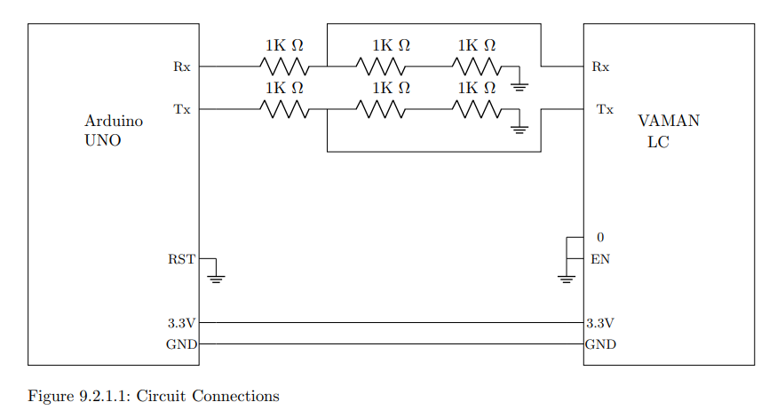
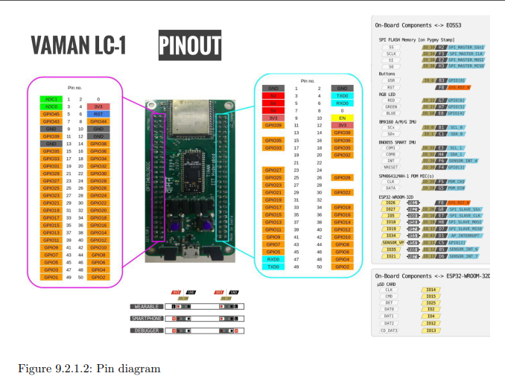
- Connect the long leg of LED to the pin number 2 on VAMAN.
- Connect the short leg of LED to the GNG using resistor.
STEPS TO BE FOLLOWED WHILE PERFORMING ESP:
- TERMUX:
- Open Termux.
- Proot-distro login Debian
- Nvim
- ALT+O
- Navigate to the code path: “/FWC-1/digital-design/vaman/esp32/codes/ide/blink/src/main.cpp” [for wired]
- Navigate to the code path: “/FWC-1/digital-design/vaman/esp32/codes/ide/ota/src/main.cpp” [for wireless]
- Open the code file make the changes as required.
- After that navigate to the path: “/FWC-1/digital-design/vaman/esp32/codes/ide/blink/src” [for wired]
- After that navigate to the path: “/FWC-1/digital-design/vaman/esp32/codes/ide/ota/src” [for wireless]
- Then click “SHIFT+S”
- Pio run
- After successful execution follow the below steps.

- ARDUINODROID:
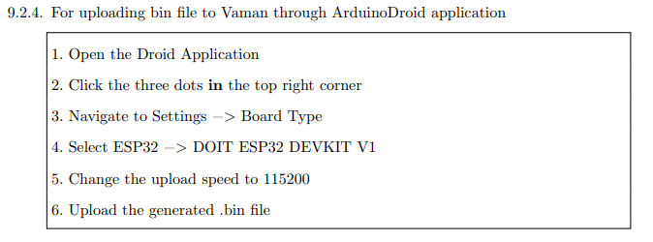
.bin file location[wired] = /sdcard/FWC-1/digital-design/vaman/esp32/codes/ide/blink/.pio/build/esp32doit-devkit-v1/firmware.bin
.bin file location[wireless] = /sdcard/FWC-1/digital-design/vaman/esp32/codes/ide/ota/blink/.pio/build/esp32doit-devkit-v1/firmware.bin
NOTE: Before starting to upload the code to the vaman make the following clicks. It will reset the board and makes it ready for upload.
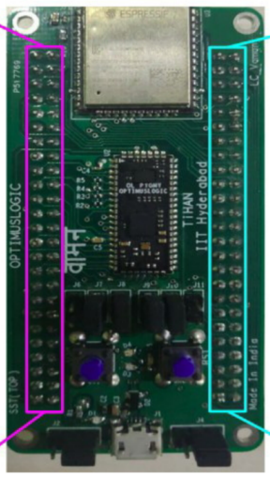
1
2
- Open ARDUINODROID.
- Click on three dots.
- Click on Upload.
- Click on Upload Precompiled.
- Go to the bin file and upload.
- Remove the EN connection from the breadboard immediately after starting to upload.
- After completion of upload remove the 0 connection from the breadboard.
- For wired:
- Connect the mobile to the vaman and check for the output.
- For Wireless:
- Connect the mobile to the vaman and turn on your hotspot.
- Check whether the vaman got connected to your hotspot, make sure that it is connected to the hotspot.
- The output will be generated immediately when the vaman gets connected to the hotspot.

Expression:
F = X' Z' + Y Z'
Truth Table:
X Y Z F
0 0 0 1
0 0 1 0
0 1 0 1
0 1 1 1
1 0 0 0
1 0 1 0
1 1 0 1
1 1 1 1

ARDUINO CODE:
// Define the digital pins for LEDs
const int LED_X = 2; // Assuming X is connected to pin 2
const int LED_Y = 3; // Assuming Y is connected to pin 3
const int LED_Z = 4; // Assuming Z is connected to pin 4
const int LED_F = 5; // Output LED connected to pin 5

void setup() {
// Initialize digital pins for LEDs
pinMode(LED_X, INPUT_PULLUP); // Using internal pull-up resistors
pinMode(LED_Y, INPUT_PULLUP);
pinMode(LED_Z, INPUT_PULLUP);
pinMode(LED_F, OUTPUT);
}

void loop() {
// Read the inputs from jumpers connected to power rails
int X = digitalRead(LED_X);
int Y = digitalRead(LED_Y);
int Z = digitalRead(LED_Z);

// Evaluate the boolean expression
int F = (!X && !Z) || (Y && Z);

// Display the output on LED connected to pin 5
digitalWrite(LED_F, F);

// Delay for stability
delay(100);
}

ESP-OTA CODE:
//----------------------Skeleton Code--------------------//
#include <WiFi.h>
#include <WiFiUdp.h>
#include <ArduinoOTA.h>

// Can be client or even host //
#ifndef STASSID
#define STASSID "gvv" // Replace with your network credentials
#define STAPSK "abcd"
#endif

const char* ssid = STASSID;
const char* password = STAPSK;

void OTAsetup() {
WiFi.mode(WIFI_STA);
WiFi.begin(ssid, password);
while (WiFi.waitForConnectResult() != WL_CONNECTED) {
delay(5000);
ESP.restart();
}
ArduinoOTA.begin();
}

void OTAloop() {
ArduinoOTA.handle();
}
//-------------------------------------------------------//

// Define the digital pins for LEDs
const int LED_X = 2; // Assuming X is connected to pin 2
const int LED_Y = 3; // Assuming Y is connected to pin 3
const int LED_Z = 4; // Assuming Z is connected to pin 4
const int LED_F = 5; // Output LED connected to pin 5

void setup(){
OTAsetup();

//-------------------//
// Custom setup code //
//-------------------//
pinMode(LED_X, INPUT_PULLUP); // Using internal pull-up resistors
pinMode(LED_Y, INPUT_PULLUP);
pinMode(LED_Z, INPUT_PULLUP);
pinMode(LED_F, OUTPUT);
}

void loop() {
OTAloop();
delay(10); // If no custom loop code ensure to have a delay in loop

//-------------------//
// Custom loop code //
//-------------------//
// Read the inputs from jumpers connected to power rails
int X = digitalRead(LED_X);
int Y = digitalRead(LED_Y);
int Z = digitalRead(LED_Z);

// Evaluate the boolean expression
int F = (!X && !Z) || (Y && Z);

// Display the output on LED connected to pin 5
digitalWrite(LED_F, F);

// Delay for stability
delay(100);
}

